**Drone Simulator to track and guide the drone in predefined flight path**

Contents

Goals 2

Introduction 2

Proposed design 3

Development details 5

Future Plan  6

Goals

Goal of this project is to create a drone simulator which can track the drone and guide the drone in pre-defined flight path.

Introduction

Drones are used in variety of fields to perform various actions such as package delivery, agriculture, transportation, aerial survey, movie making etc.,

All the above-mentioned use cases require more processing power and produces ton of data while performing the duty.

This simulator project is just the starting point. But my long-term goal is to build Drone AKS platform service to provide custom solutions to drone users as a subscription service.

Drone users will get the drone-edge along with their subscription to Azure drone service. Drone edge will come with pre-installed apps to handle drone use cases. Also, drone edge acts as a backup device to store all the drone data and uploads to the backend drone AKS platform service over wi-fi.

The user can access the drone captured video or drone operational data over azure cloud. For example, in case of drone package delivery the video must be kept in the cloud as a prof of delivery. Also, this data can be used to further improve the delivery process and operational efficiency.

Drone users can use other azure services such as Azure data bricks, azure data factory, azure SQL DB etc., to store and perform various actions on their data. This subscription service have a potential to bring business opportunities for other azure platform services such as azure compute, azure data, azure data explorer, azure networking, azure databox etc.,

**Proposed Design**

**System Design**

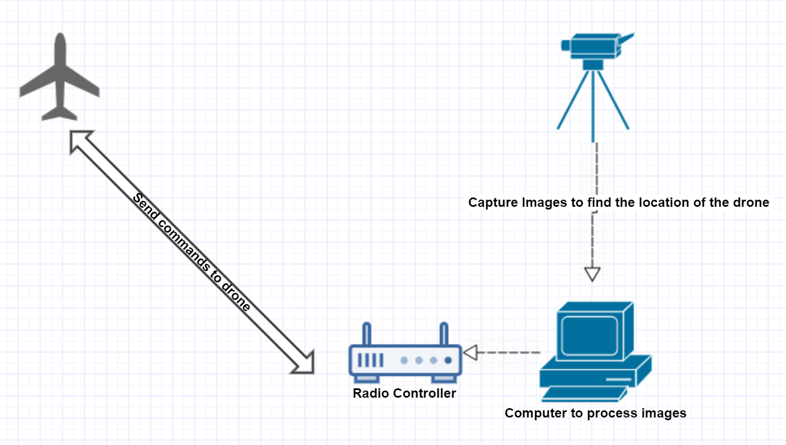

* User selects the predefined flight path through user interface.
* The simulator guides the drone to follow the predefined flight path.
* Simulator uses the simulated camera to know the current position of the drone in 3D space.
* Then the simulator issues the required correction to the drone path.

**Class diagram**

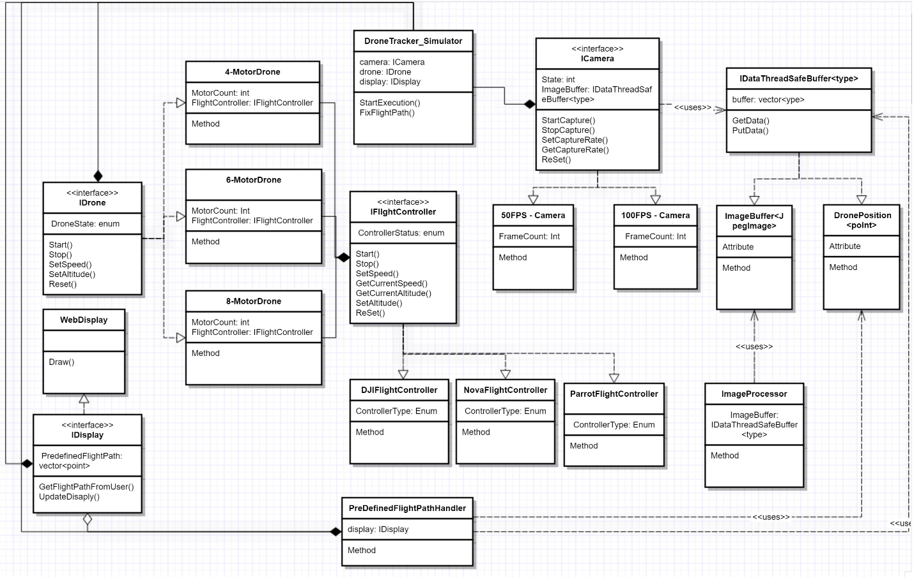

**Development details**

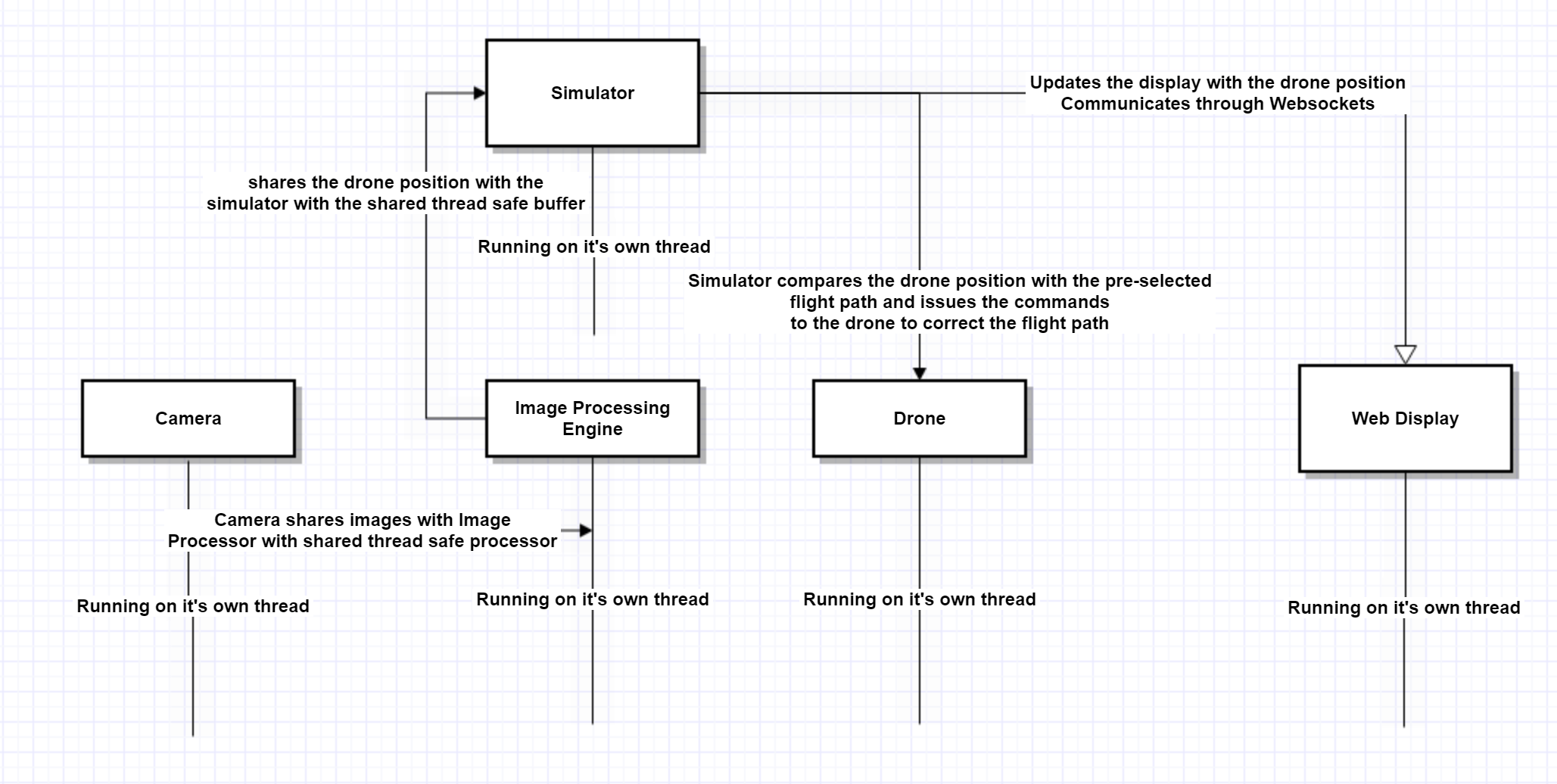

* Since it is a simulator it doesn’t involve any hardware component. I will create simulated camera, drone.
* The simulated software components shared data through a thread safe buffer.
* Each simulated component exposes an API. The communication between the simulated object happens through the API.
* All simulated components will be running on their own thread.

**Future Plan**

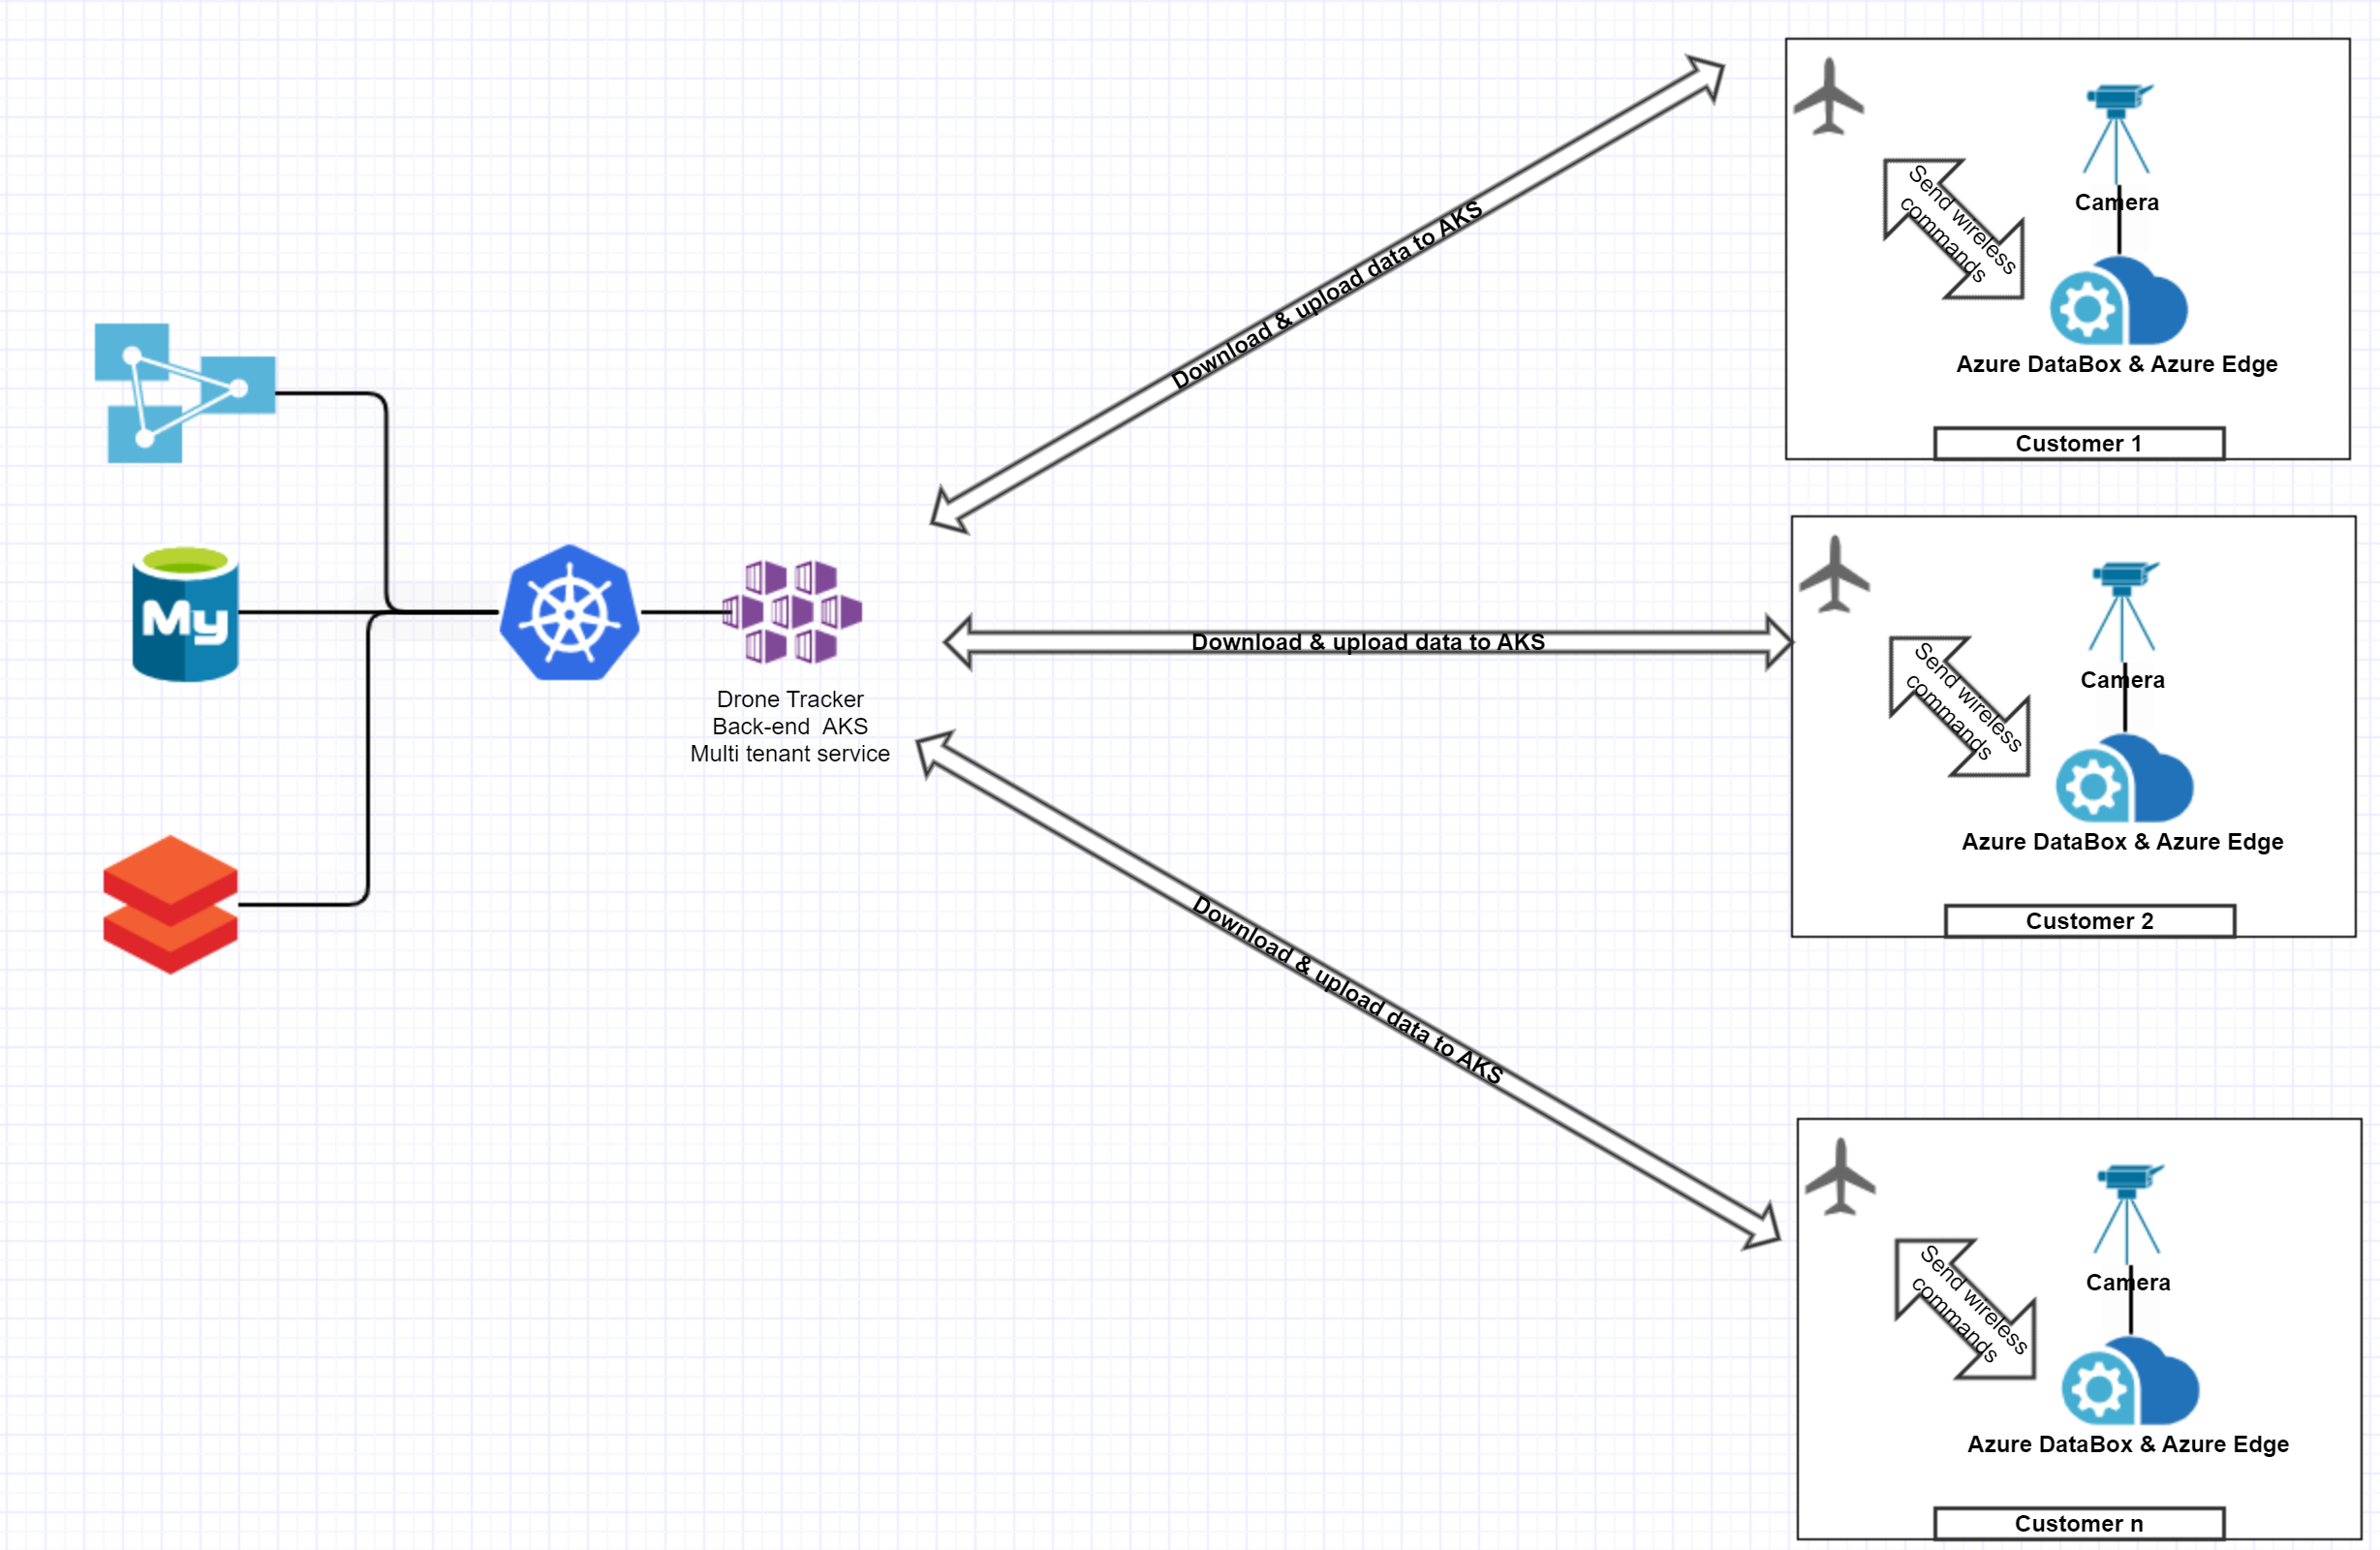

* Drones are used for various jobs such as package delivery, Agriculture, capturing videos etc., All the use cases require large processing power and deals with large amount of data.
* I am proposing a business model where drone user will buy drone edge device from Microsoft on a subscription basis.
* The edge can support customer action through locally installed app on the edge device. For example, if it is used to capture video the local edge device comes with a feature to upload the video to the backend AKS. User can access the data from the cloud and use other azure services to process it further.
* I build Azure Kubernetes Service backend platform service which deals with various workloads from drone users.